Sculthorpe Parish Council

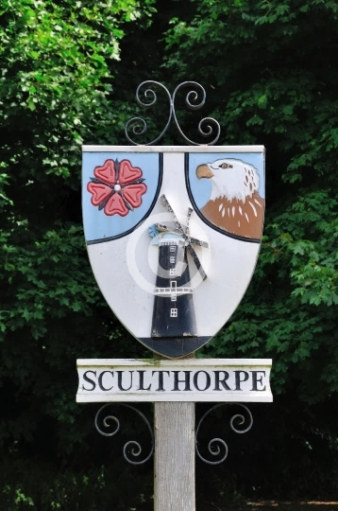

Meeting Minutes

**Date** Wednesday 4 September 2024

1. **Welcome and to receive apologies for absence**

*Chairman welcomed those present and accepted apologies from Cllr Dawson.*

*Minutes were taken by the Chairman in the Clerks’ absence.*

1. **Receive declarations of interest and requests for dispensations by Councillors**

*None*

1. **Minutes of meeting held on 7 July to be approved**

*The minutes were approved without amendment and signed by the chairman as a correct record.*

1. **To report progress on items not on the agenda from the last meeting**.

*None.*

1. **To hear from NNDC and NCC Councillors, if attending**.

*Cllr Tom Fitzpatrick reported that the District council are required to make financial savings. This includes a proposal to close toilet facilities locally. Production of a roundabout on the Fakenham bypass as part of the long-term development plan for Fakenham is to begin shortly.*

1. **Open forum for Public Participation: an opportunity to hear from members of the public.**

*Questions were received surrounding the current use of bowling club and its state of disrepair. Chairman assured the Parishioners that the PC have it in hand. Informed that Brian Watkin has now left the village and a new resident has moved in.*

7.     **To receive updates from council members and agree any action required.**

**7.1 Speed Watch report.** *The community speed watch team did not meet during August due to holiday but started again today. No one caught yet, however, 2 speeders were identified in July.*

**7.2 SAM2 report.** SAM2 camera continued to record excessive speeds within the village.

**7.3 Village Hall Committee report** – *Coffee mornings getting busier.*

**7.3.1 Discuss the Hall Committees responsibility/ownership of the Village Hall.**

*The Village Hall Committee have advised the PC that they do not want sole responsibility for managing the village hall. They wish to continue with the day to day running of the charity but also wish to work in partnership with the PC on all and any bigger projects. This would require the PC to become involved in all aspects of the running of the village hall committee including financial matters. Following discussions with, and input from, Cllr Fitzpatrick, the PC resolved to consult legal advice from the suggested law firm NP Long, via NALC. The PC would like legal information regarding their current involvement in the village hall and further information on what is required for the PC to become the custodian trustee of the Village Hall Committee, any change in governing document required and for the land to remain registered within the Parish under a custodian trustee.*

**7.3.2 Discuss village hall insurance policy**.

*VHC proposed PC send the payment to insurance company then the VHC reimburse PC. This is for insurance purposes only. Insurance company will not insure building unless PC send funds. Cllr Read Proposed we pay, Cllr Ramm seconded.*

**8. Open Spaces**

**8.1 To discuss and report any highways issues that may have arisen.**

*Cllr London reported traffic problems at the junction of Moor Lane and The Street. Too busy with both farm traffic and busses. Please report to highways for advice. Suggested that contact is made with Kings Lynn Borough Council for consideration of parking attendants visiting the village.*

**8.2 Blacketts pond area update.**

*No further updates.*

**8.3 Receive update on the Bowls Club**

*Cllr Read proposed to return monies to current renter, Cllr Lissack seconded. PC to retain control.*

**8.4 Consider and agree to level the playing park/field.**

*Fenland farm partnership agreed to assist with land management FOC but advised that it needs ongoing management.*

**8.5 Discuss the overgrown brambles on Moor lane.**

*Cllr Ramm contacted highways, agreed to contact the owner*. *Not yet been done.*

**9. Planning Matters**

**9.1 To receive results of applications.**

**9.2 To receive and consider new applications.**

**10.  Receive and consider Correspondence**.

**11.   Financial Matters**

**11.1 To approve the bank reconciliation and payment of accounts list.**

*Approved.*

**12. Receive items for next agenda and note the date of the next meeting**

Dog Bin on Fakenham Road.

Hedge cutting incentive from highways.

Francis Beckham Trust representative.

Next meeting 6th Nov

Meeting Closed @ 2050hrs